***Site Purpose:***

This site will help customers getting acquainted with other similar businesses on town, that could provide more information on different phases of their business.  
New Government laws will be easily presented with more information and help.  
The events posted could give them the opportunities to present their portfolio to future clients.

***Target Audience:***

New owners of new business.  
People looking form new opportunities to grow their businesses.   
Owners looking for everts where to invest on advertising.  
Universities looking for good places where to appoint their students while they growth on their carriers.  
Accountants looking for specific laws needed on their client businesses.

Site Map:  
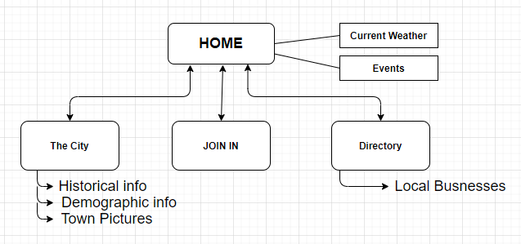

Color Scheme:   
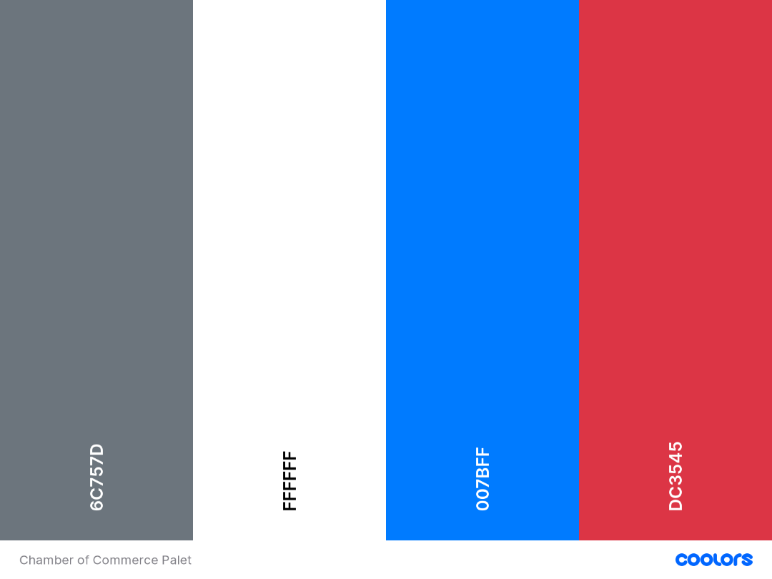

Typography:   
Font-family:

* Montserrat
* Open Sans
* Roboto

Wireframe Sketches:

For Large Screens:  
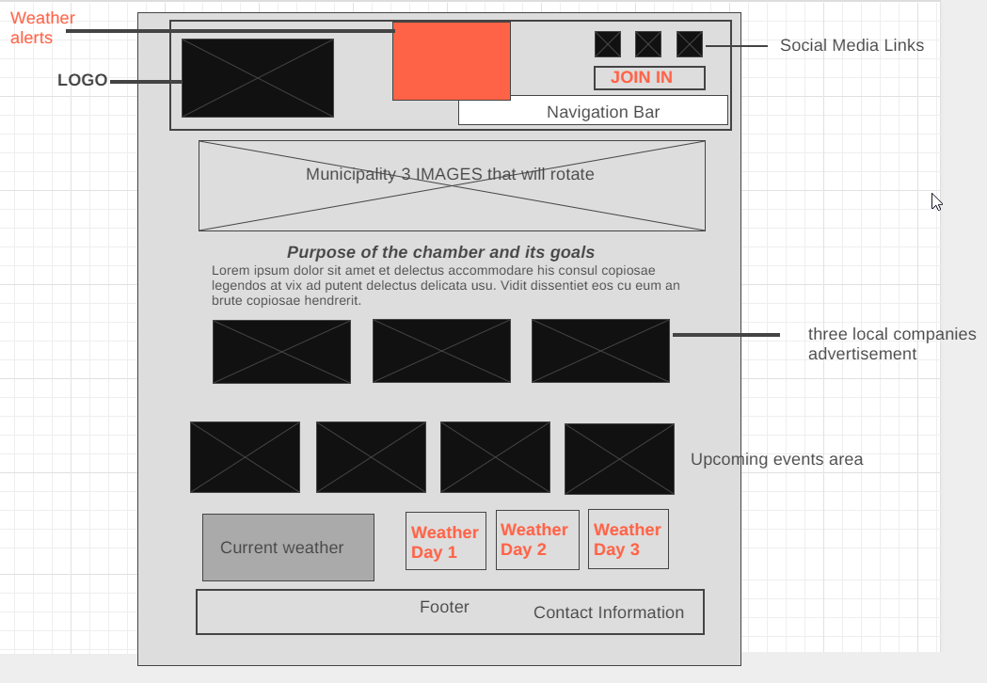

For Medium:  
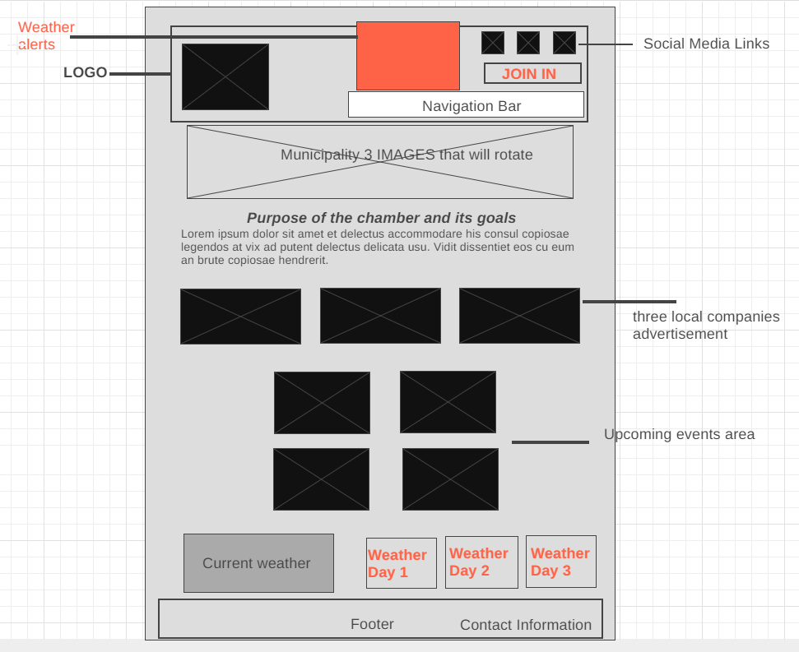

For Small screen:  
